**a.html**

<!DOCTYPE html>

<html lang="en">

<head>

    <meta charset="UTF-8">

    <meta name="viewport" content="width=device-width, initial-scale=1.0">

    <title>Document</title>

</head>

<body style="background-image: url(modern-desktop-background-geometric-blue-design-vector_53876-135923.avif);color: white;">

  <center> <h1>this is a.html file</h1>

    <a href="b.html">click hee to enter in b.html</a>

</center>

</body>

</html>

**b.html**

<!DOCTYPE html>

<html lang="en">

<head>

    <meta charset="UTF-8">

    <meta name="viewport" content="width=device-width, initial-scale=1.0">

    <title>Document</title>

</head>

<body style="background-image: url(gradient-futuristic-background-with-spheres_23-2149110136.avif);color: white;">

    <center><h1>this is b.html file</h1>

    <a href="a.html"> click here to enter in a.html</a>

</center>

</body>

</html>

**Output screens:**

**Screen 1**

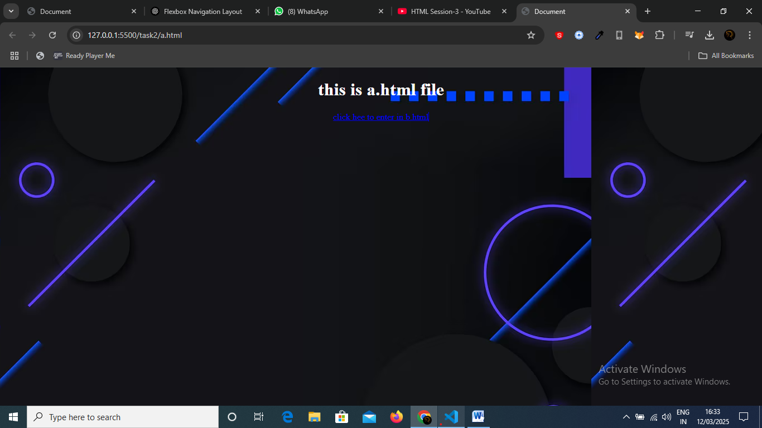

**Screen 2 :**

